Ping and Traceroute – Lab
This document contains my responses to the provided Ping and Traceroute lab.
The topology and addressing were supplied as part of the lab instructions.

Topology:
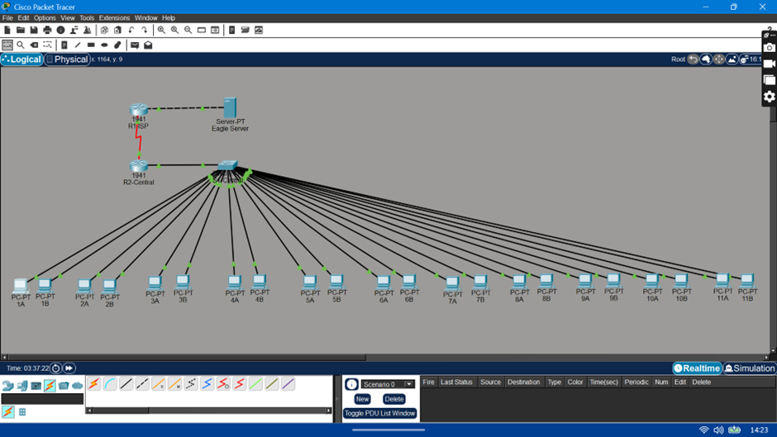
The topology includes:
- 2 Routers: R1-ISP and R2-Central
- 1 Server: Eagle Server
- 1 Switch: S1-Central
- 11 Pods: Each pod contains two host PCs

Addressing Table

Device | Interface | IP Address | Subnet Mask | Default Gateway
R1-ISP | S0/0/0 | 10.10.10.6 | 255.255.255.252 | N/A
 | Fa0/0 | 192.168.254.253 | 255.255.255.0 | N/A
R2-Central | S0/0/0 | 10.10.10.5 | 255.255.255.252 | N/A
 | Fa0/0 | 172.16.255.254 | 255.255.0.0 | N/A
Eagle Server | N/A | 192.168.254.254 | 255.255.255.0 | 192.168.254.253
 | N/A | 172.31.24.254 | 255.255.255.0 | N/A
hostPod#A | N/A | 172.16.Pod#.1 | 255.255.0.0 | 172.16.255.254
hostPod#B | N/A | 172.16.Pod#.2 | 255.255.0.0 | 172.16.255.254
S1-Central | N/A | 172.16.254.1 | 255.255.0.0 | 172.16.255.254

Task 1: Use the ping Command to Verify Simple TCP/IP Network Connectivity.
Step 1: Verify TCP/IP Network layer connectivity on the local host computer.
Command Used: ipconfig
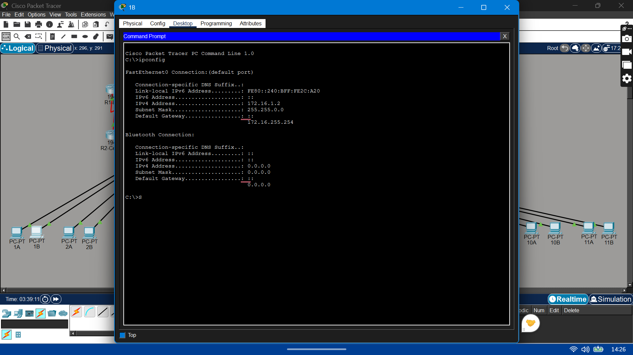
- Recorded information about local TCP/IP network information:

TCP/IP Information | Value
IP Address | 172.16.1.2
Subnet Mask | 255.255.0.0
Default Gateway | 172.16.255.254

- Use the ping command to verify TCP/IP Network layer connectivity on the local host computer.
Command Used: ping 172.16.1.2
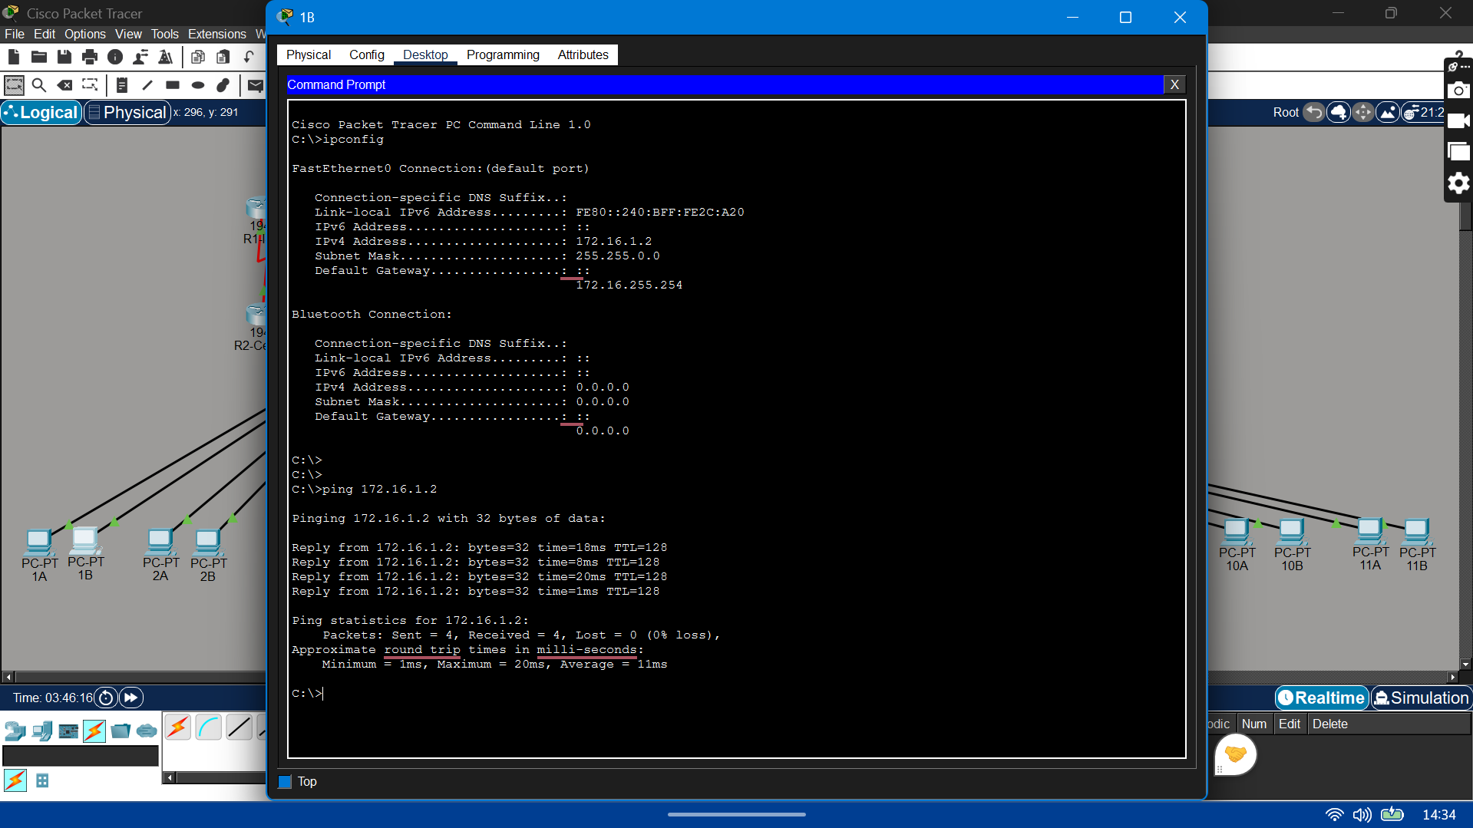
- Observed results of the ping command on my computer:

Field | Value
Size of packet | 32 bytes
Number of packets sent | 4
Number of replies | 4
Number of lost packets | 0
Minimum delay | 1ms
Maximum delay | 20ms
Average delay | 11ms

Step 2: Verify TCP/IP Network layer connectivity on the LAN.
Command Used: ping 172.16.255.254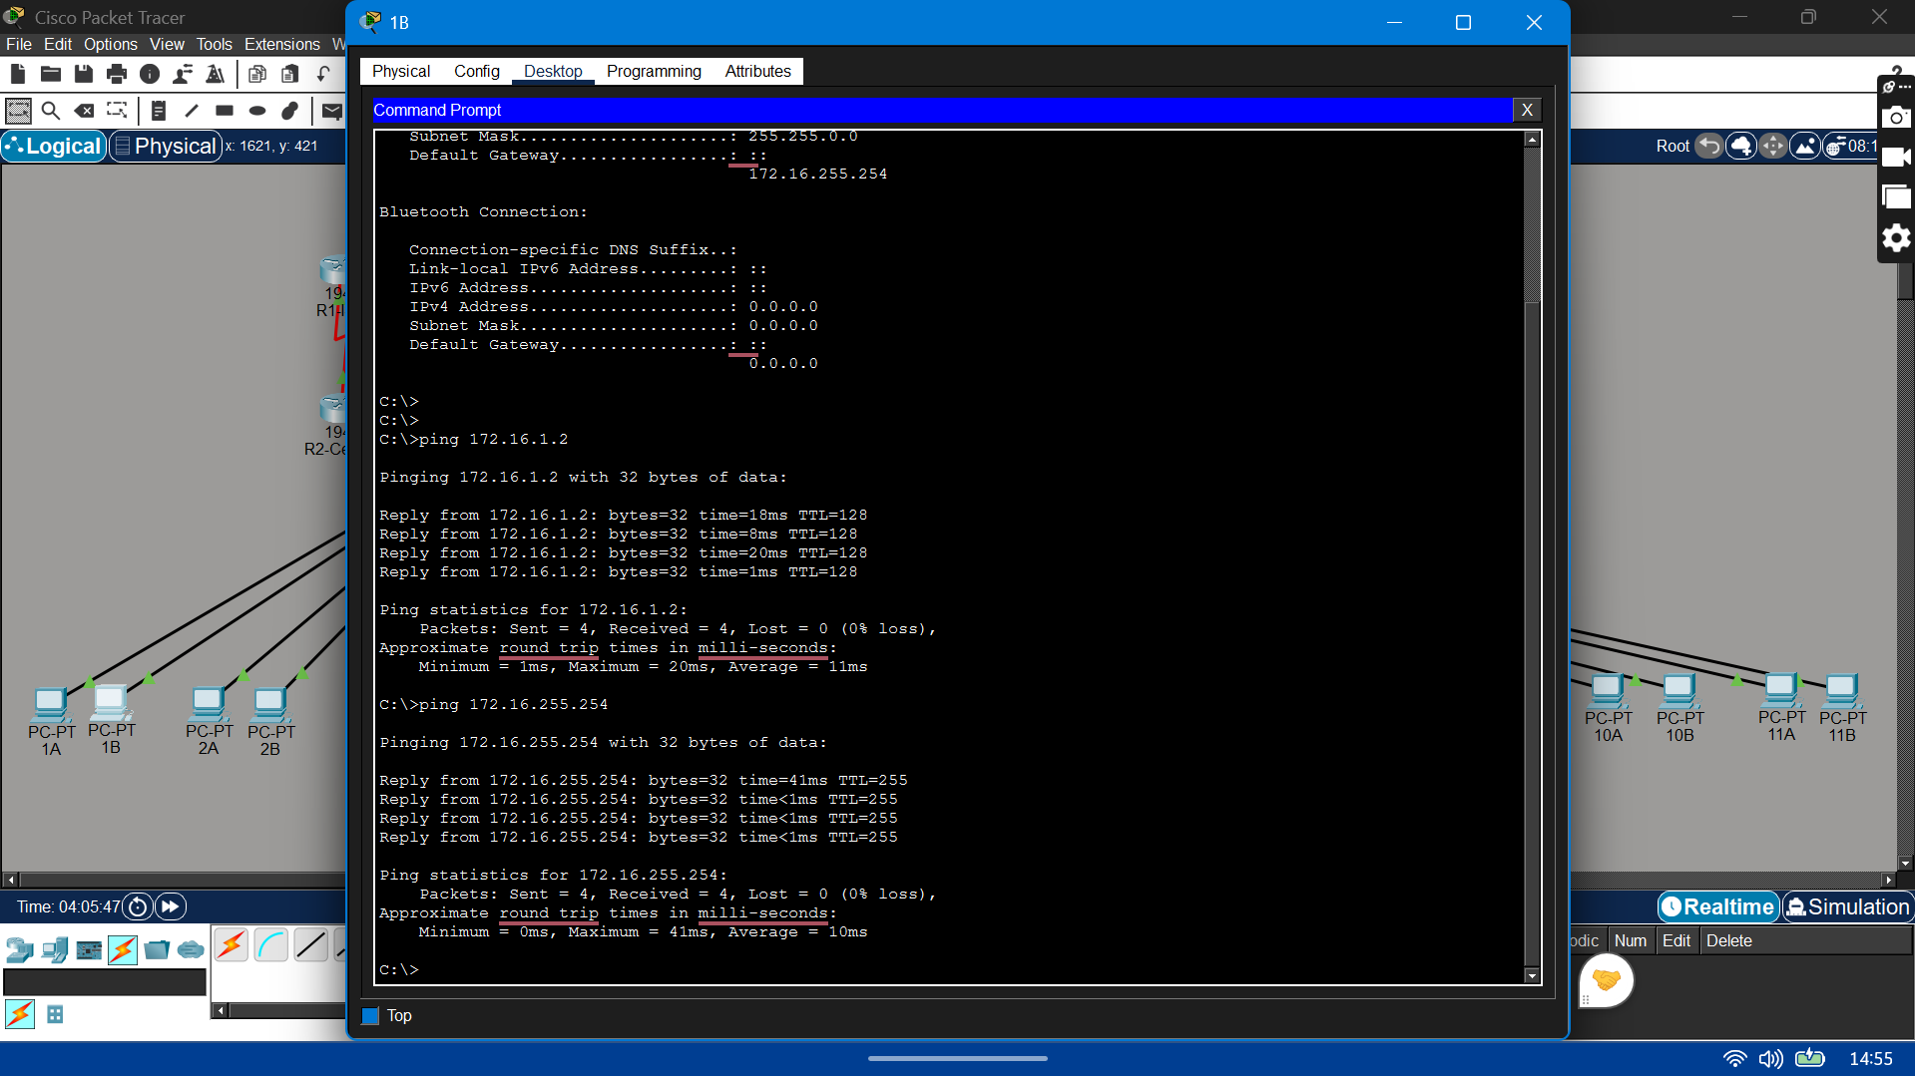
- Results of the ping command to the default Gateway:
Field | Value
Size of packet | 32 bytes
Number of packets sent | 4
Number of replies | 4
Number of lost packets | 0
Minimum delay | 0ms
Maximum delay | 41ms
Average delay | 10ms

What would be the result of a loss of connectivity to the default gateway?
If the default gateway is lost:
- PCs can still communicate with each other since they're all on the same 172.16.0.0/16 network
- PCs cannot reach anything outside their network — no Eagle Server, no R1-ISP, no internet
- Basically local traffic works but all external communication fails.

Step 3: Verify TCP/IP Network layer connectivity to a remote network.
Command Used: ping 192.168.254.254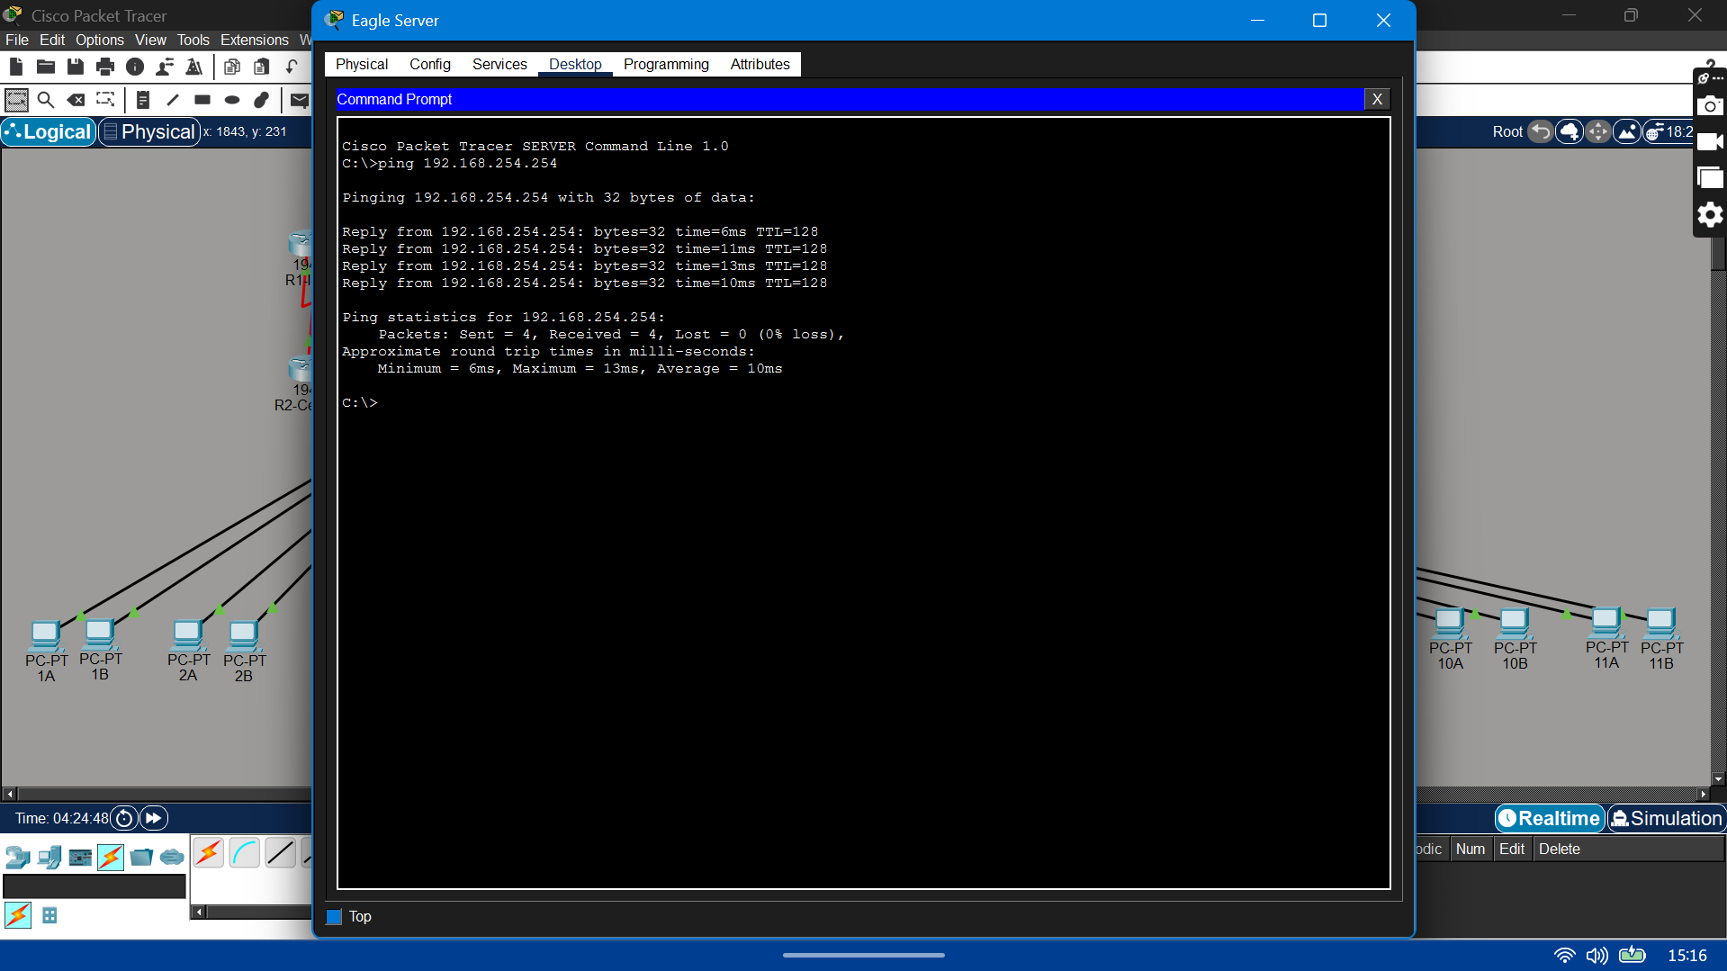
- Results of the ping command on my computer:

Field | Value
Size of packet | 32 bytes
Number of packets sent | 4
Number of replies | 4
Number of lost packets | 0
Minimum delay | 6ms
Maximum delay | 13ms
Average delay | 10ms

Task 2: Use the tracert Command to Verify TCP/IP Connectivity.
Step 1: Verify TCP/IP Network layer connectivity with the tracert command.
Run: tracert 192.168.254.254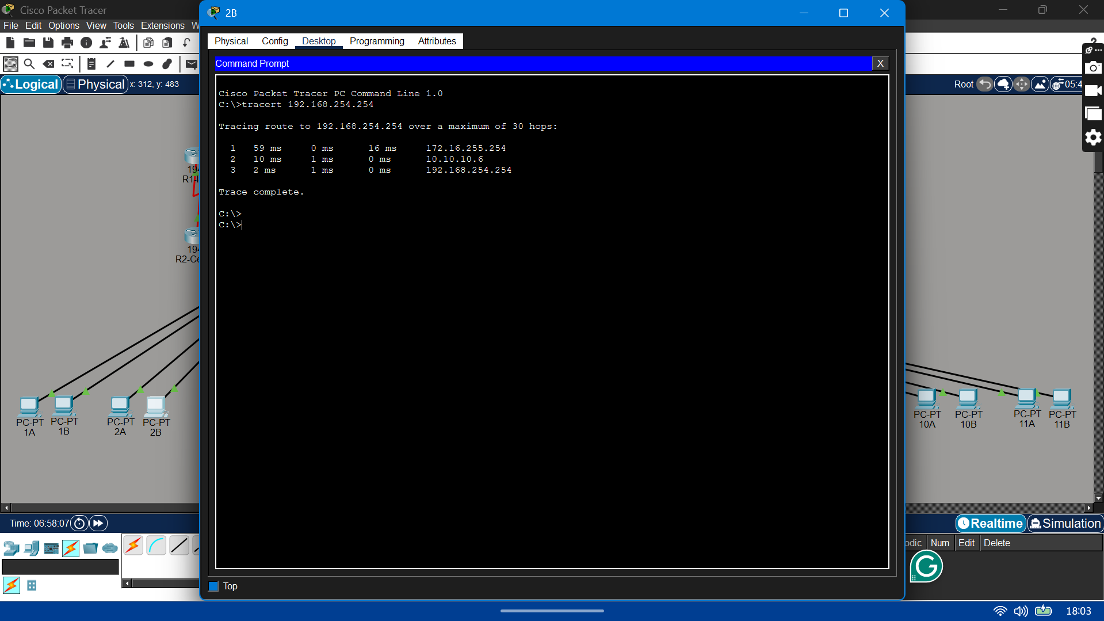
- Record your result in the following table:
Field | Value
Maximum number of hops | 30
First router IP address | 172.16.255.254
Second router IP address | 10.10.10.6
Destination reached? | Yes

Step 2: Observe tracert output to a host that lost network connectivity.
Run: tracert -w 5 -h 4 192.168.254.254
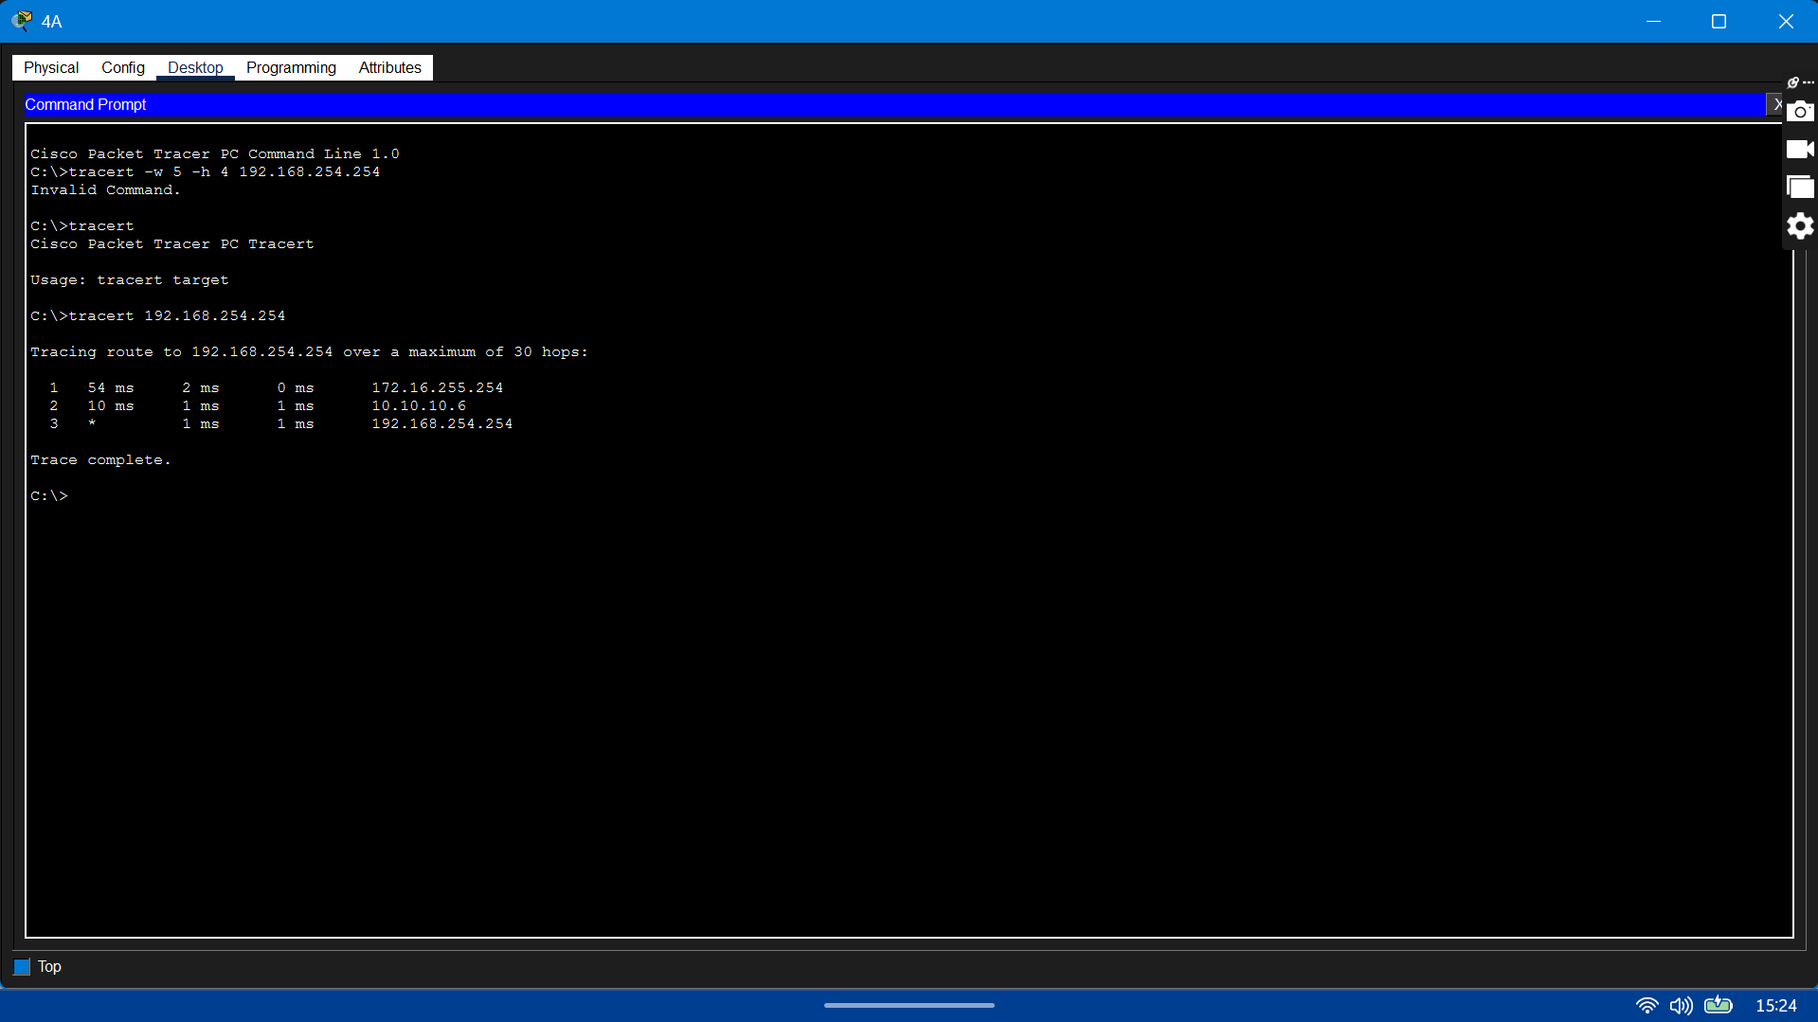
What would the tracert output be if R1-ISP failed?
Traceroute would stop at R2-Central and would not reach the destination.
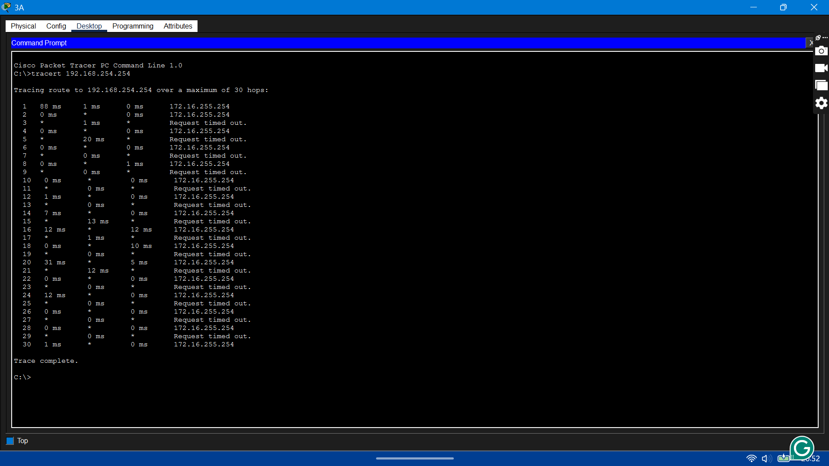
What would the tracert output be if R2-Central failed?
Traceroute would fail at the first hop (172.16.255.254), and the destination would not be reachable.
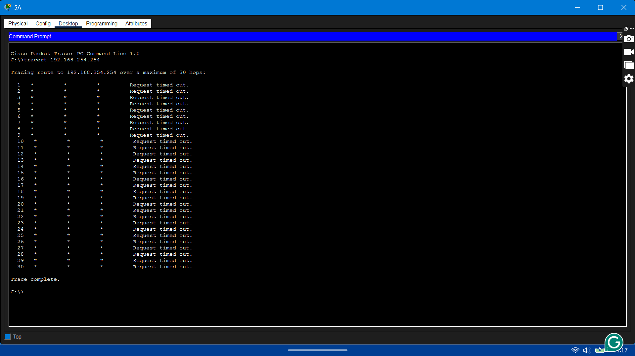

Task 3: Challenge
Output of a ping Command using the –t Option
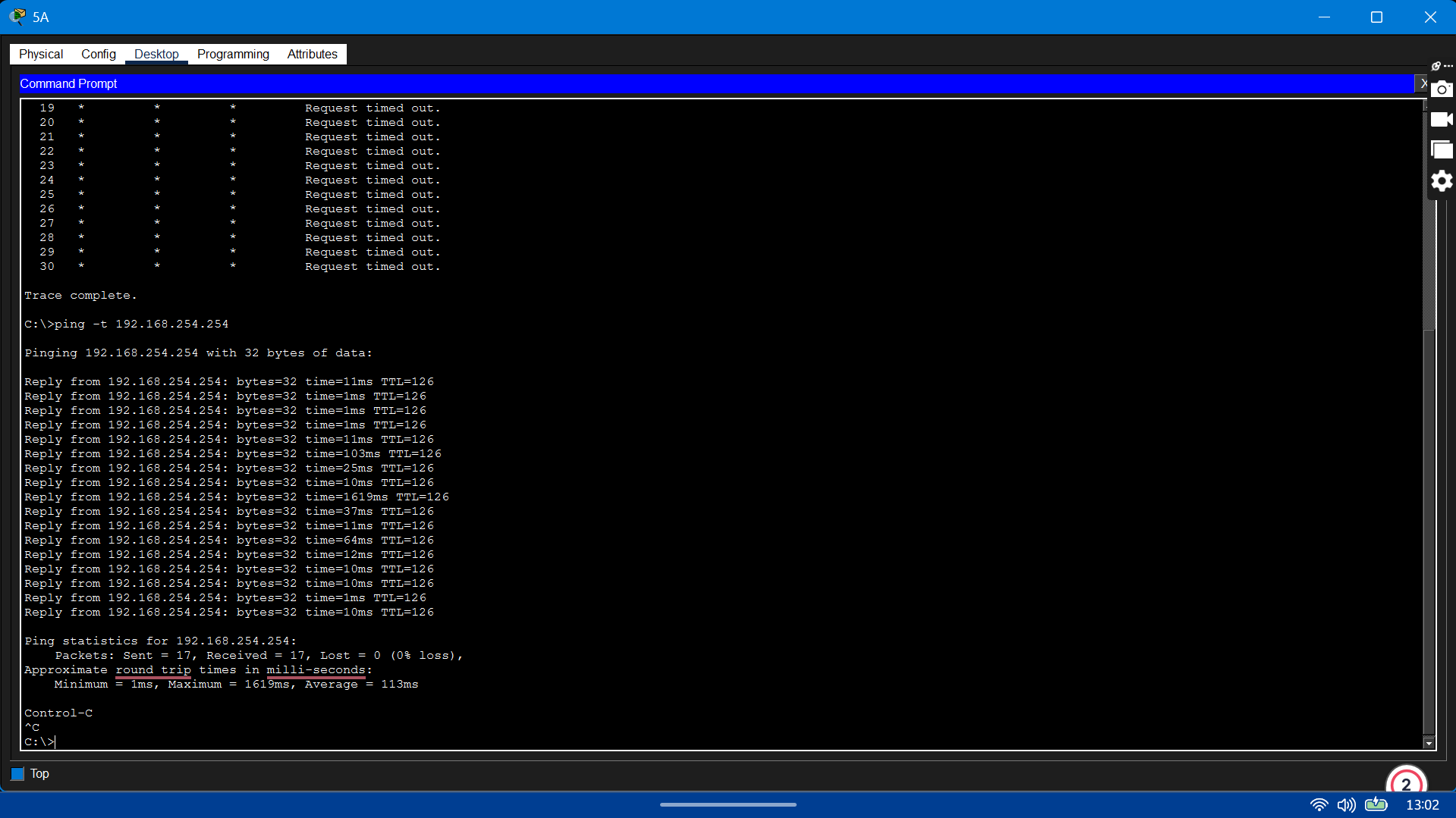

Output of a ping Command using the –n and –r Options
